1. Install Docker and docker-compose on ng-vm1:  
   Install Docker: <https://docs.docker.com/engine/install/ubuntu/>

Install Docker-compose sudo apt install docker-compose.

1. A docker compose file has been created to pull PostgreSQL DB image, pgadmin image to administrate the DB (also adminer is a good tool to administrate the DB):  
   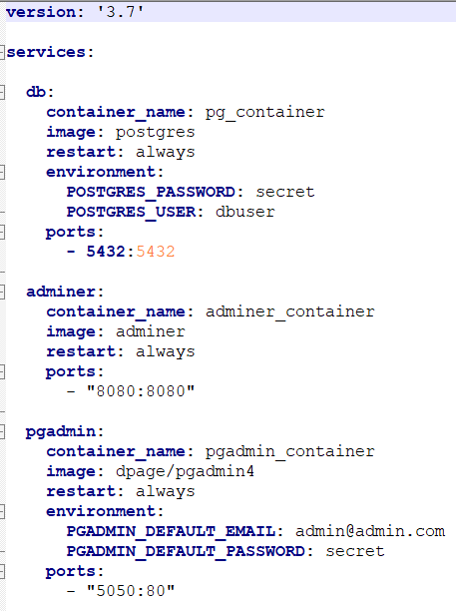  
     
   This file contains credentials, so usually we do not upload it to GitHub, but will skip this recommendation for now.
2. Upload this file to ng-vm1, then sudo docker-compose up.  
   This will run containers with those images with the options -it and the other options specified in the file like -p.

1. Connect pgadmin with PostgreSQL:
   1. go to <http://localhost:5050> and login:  
      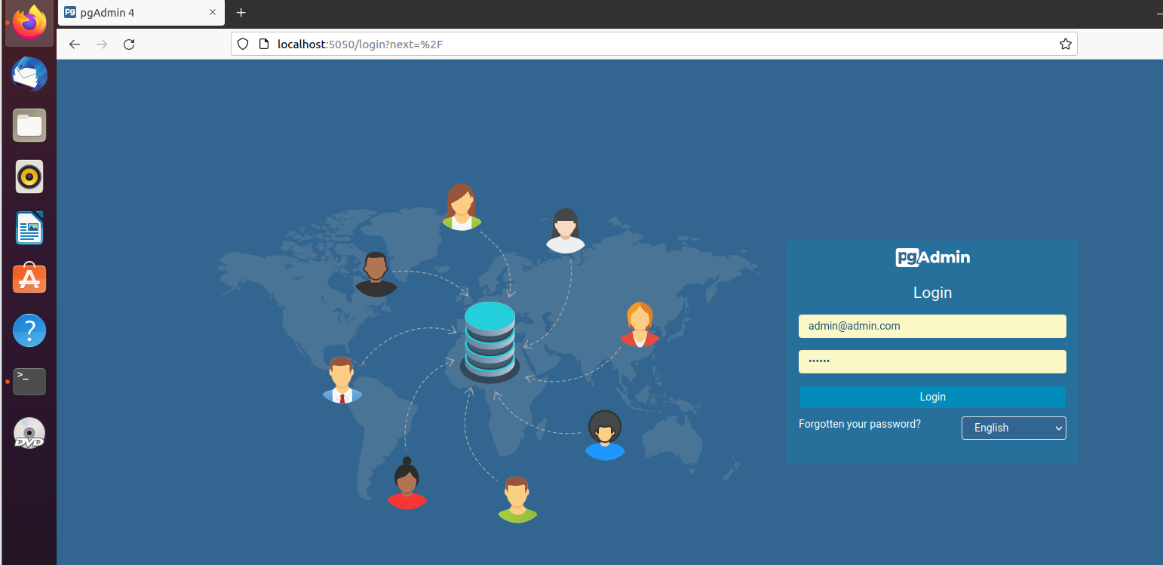
   2. add a server:  
      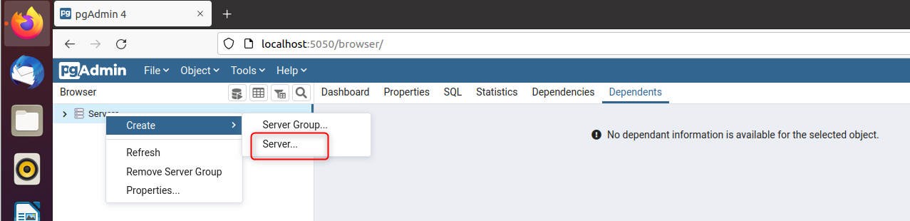
   3. before we proceed, since the pgadmin and PostgreSql are running in containers in the same VM, the pgadmin needs to know PostgreSql IP inside docker network, we cannot use localhost. To get that:  
        
      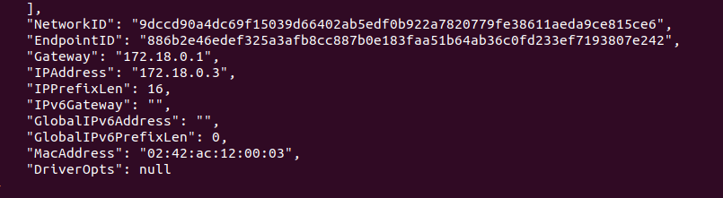
   4. Now go back to create a server in pgadmin:  
      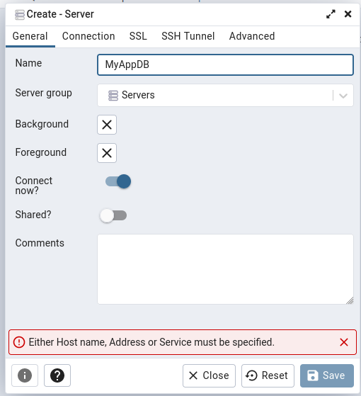  
        
      add the IP we got, the port is 5432, the username and password are specified in the docker-compose file.  
      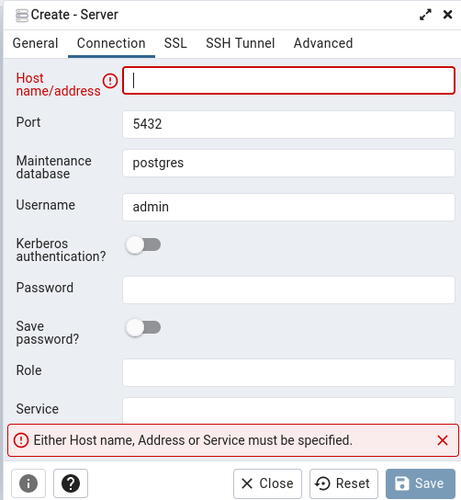
   5. Then PostgreSql DB appears:  
      